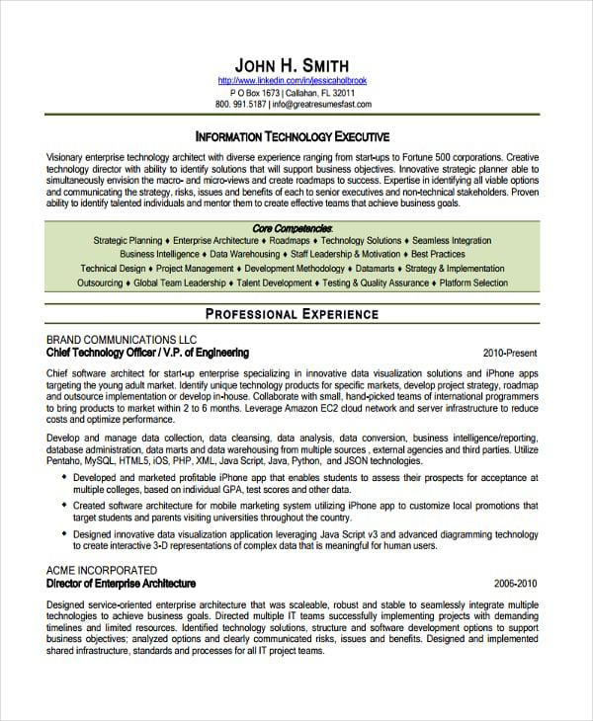
JOHN H. SMITH
http://www.linkedin.com/in/jessicaholbrook
PO Box 1673 | Callahan, FL 32011 800.991.5187 | info@greatresumesfast.com
INFORMATION TECHNOLOGY EXECUTIVE
Visionary enterprise technology architect with diverse experience ranging from start-ups to Fortune 500 corporations. Creative technology director with ability to identify solutions that will support business objectives. Innovative strategic planner able to simultaneously envision the macro- and micro-views and create roadmaps to success. Expertise in identifying all viable options and communicating the strategy, risks, issues and benefits of each to senior executives and non-technical stakeholders. Proven ability to identify talented individuals and mentor them to create effective teams that achieve business goals.
Core Competencies
Strategic Planning Enterprise Architecture Roadmaps Technology Solutions⚫ Seamless Integration Business Intelligence Data Warehousing Staff Leadership & Motivation Best Practices
Technical Design Project Management Development Methodology Datamarts Strategy & Implementation Outsourcing Global Team Leadership Talent Development Testing & Quality Assurance Platform Selection
PROFESSIONAL EXPERIENCE
BRAND COMMUNICATIONS LLC
Chief Technology Officer/V.P. of Engineering
2010-Present
Chief software architect for start-up enterprise specializing in innovative data visualization solutions and iPhone apps targeting the young adult market. Identify unique technology products for specific markets, develop project strategy, roadmap and outsource implementation or develop in-house. Collaborate with small, hand-picked teams of international programmers to bring products to market within 2 to 6 months. Leverage Amazon EC2 cloud network and server infrastructure to reduce costs and optimize performance.
Develop and manage data collection, data cleansing, data analysis, data conversion, business intelligence/reporting, database administration, data marts and data warehousing from multiple sources, external agencies and third parties. Utilize Pentaho, MySQL, HTML5, iOS, PHP, XML, Java Script, Java, Python, and JSON technologies.
• Developed and marketed profitable iPhone app that enables students to assess their prospects for acceptance at multiple colleges, based on individual GPA, test scores and other data.
Created software architecture for mobile marketing system utilizing iPhone app to customize local promotions that target students and parents visiting universities throughout the country.
• Designed innovative data visualization application leveraging Java Script v3 and advanced diagramming technology to create interactive 3-D representations of complex data that is meaningful for human users.
ACME INCORPORATED
Director of Enterprise Architecture
2006-2010
Designed service-oriented enterprise architecture that was scaleable, robust and stable to seamlessly integrate multiple technologies to achieve business goals. Directed multiple IT teams successfully implementing projects with demanding timelines and limited resources. Identified technology solutions, structure and software development options to support business objectives; analyzed options and clearly communicated risks, issues and benefits. Designed and implemented shared infrastructure, standards and processes for all IT project teams.

